DHT11 Temperature and humidity

Saturday, April 21, 2018

6:09 PM

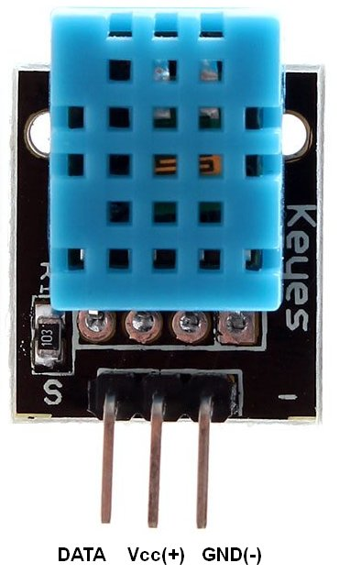

VCC to 3v+

Gnd to 3v gnd

VCC to pin 17

6 0 
5 0 
」 S 」 SO 
g ∕ 10s 

Install

Get the library:

git clone <https://github.com/szazo/DHT11_Python.git>

cd DHT11_Python

## Edit

sudo nano dht11_example.py

## 

## Code:

Import RPi.GPIO as GPIO

import dht11

import time

import datetime

# initialize GPIO

GPIO.setwarnings(False)

GPIO.setmode(GPIO.BCM)

GPIO.cleanup()

# read data using pin 17

instance = dht11.DHT11(pin=17)

while True:

result = instance.read()

if result.is_valid():

print("Last valid input: " + str(datetime.datetime.now()))

print("Temperature: %d C" % result.temperature)

print("Temperature: %d F" % ((result.temperature * 9/5)+32))

print("Humidity: %d %%" % result.humidity)

time.sleep(1)

## Execute:

python dht11_example.py